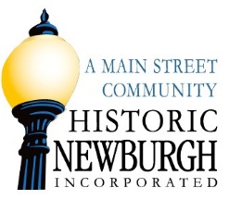
MEMBERSHIP APPLICATION
Membership Categories and Benefits
Amount | Level | Number of Complimentary tickets for Wine Fest or Ghost Walk
$35.00 | Friend | 0
$50.00 | Family | 0
$100.00 | Sustainer | 2 tickets
$250.00 | Preservation Club | 4 tickets
$500.00 | Revitalization Council | 6 tickets
$1,000.00 | Founder's Society | 8 tickets
$2,500.00 | Preservationist’s Circle | 10 tickets

Would you like to make an additional donation to:
$__________ Design /Beautification Committee $ __________ Economic Vitality Committee

Name ______________________________________________________________________________
Street Address _______________________________________________________________________
City _______________________________ State _________________ Zip________________________
Phone _______________________________________ Email: _________________________________
Check Number __________ or Credit Card Name _______________ Amount $__________________
Credit Card Number ___________________________________________________________________
Expiration Date____________ CSV Code ________
VOLUNTEER OPPORTUNITIES
_____Office/Store _____Wine Fest ____Fireworks
_____Newburgh Friday Nights ____Ghost Walk ____Newburgh Celebrates Christmas
_____Christmas Winter Lights ____Farmers Market ____Strawberry Social

